

本科实验报告

课程名称： | 计算机组成
姓 名： | 王俊
学 院： | 海洋学院
专 业： | 海洋工程与技术
学 号： | 3170100186
指导教师： | 姜晓红

2020年 5 月 7 日

报告实验6—CPU设计-控制器

课程名称： 计算机组成 实验类型： 综合
实验项目名称： CPU设计-控制器

学生姓名： 王俊 专业： 海洋工程与技术 学号： 3170100186
同组学生姓名： 指导老师： 姜晓红
实验地点： 家里 实验日期： 2020 年 5 月 7 日

一、实验目的和要求
1. Using register transfer control technology
2. Master the core of the CPU: the relationship between the instruction execution process and the control flow
3. Design the controller
4. Learning test plan design
5. Learning test program design

experiment apparatus:
- Computer (Intel Core i5 or higher, 4GB RAM or higher) system
- Spartan-3 Starter Kit Board / Sword development board
- Xilinx ISE 14.4 and above development toolsExperimental Materials：
No

- 实验内容和原理
2.1.Experimental task：
- Design a controller with 9+ instructions
Design and implement controller with hardware description language
Complete the control signal truth table according to the Exp05 data path and command coding
Replace the controller core of Exp05
This experiment is completed on the basis of Exp05
- Design the controller test plan:
OP decoding test: R-format, memory access instruction, branch instruction, transfer instruction
Operation control test: Function decoding test
- Design the controller test program
2.2.Computer Architecture
2.2.1.Computer system decomposition
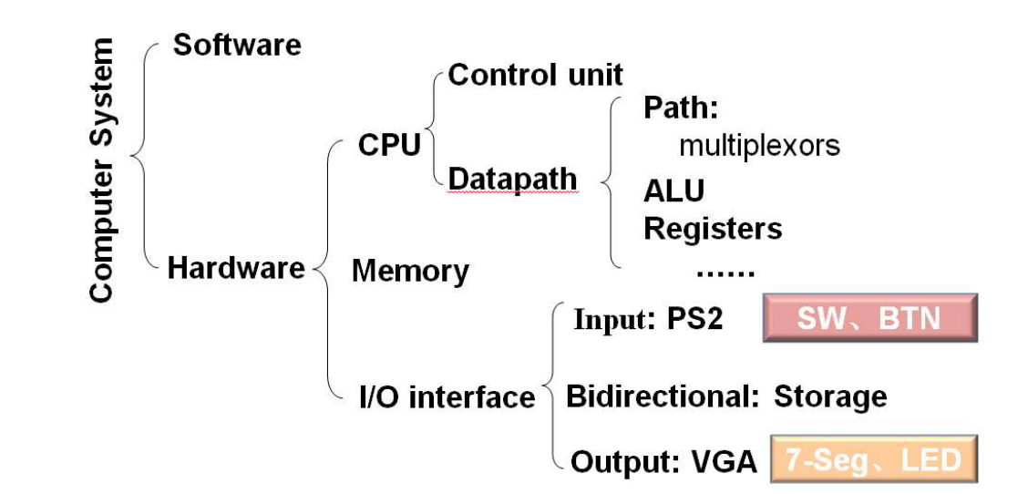

Digital circuits vs CPU organization :
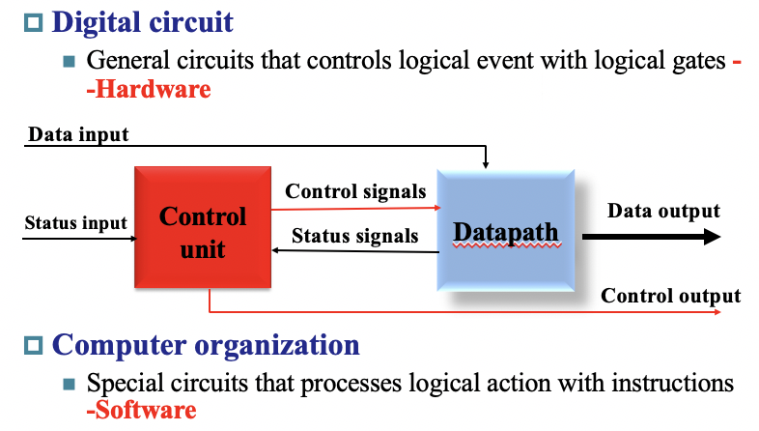
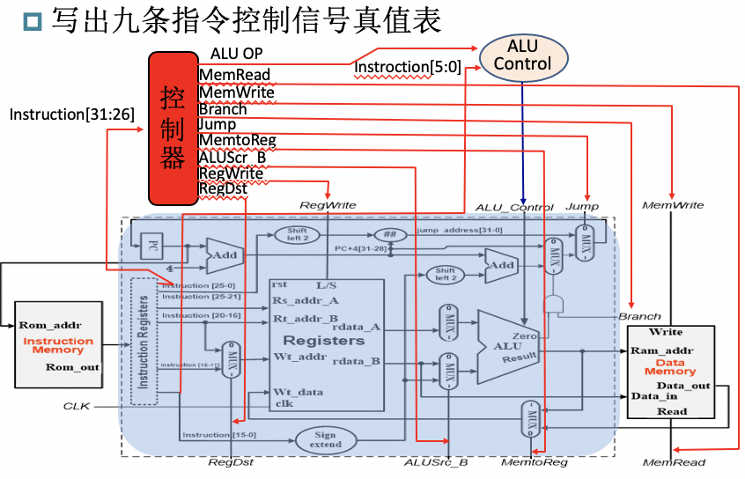
2.3.Definition of the control signal:
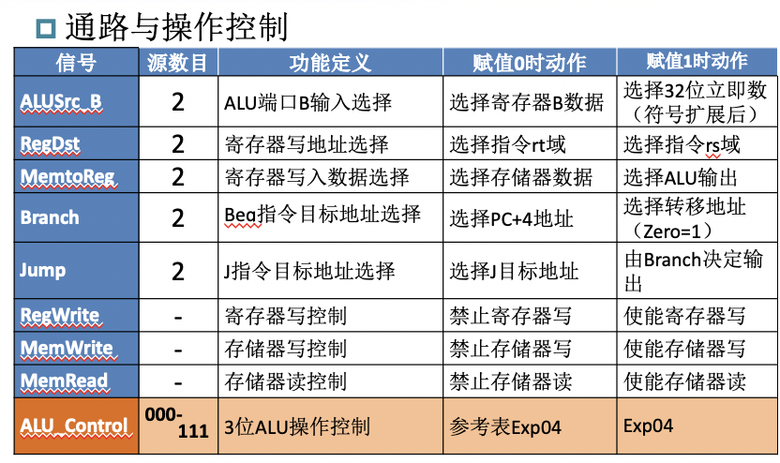

True Table for control signal
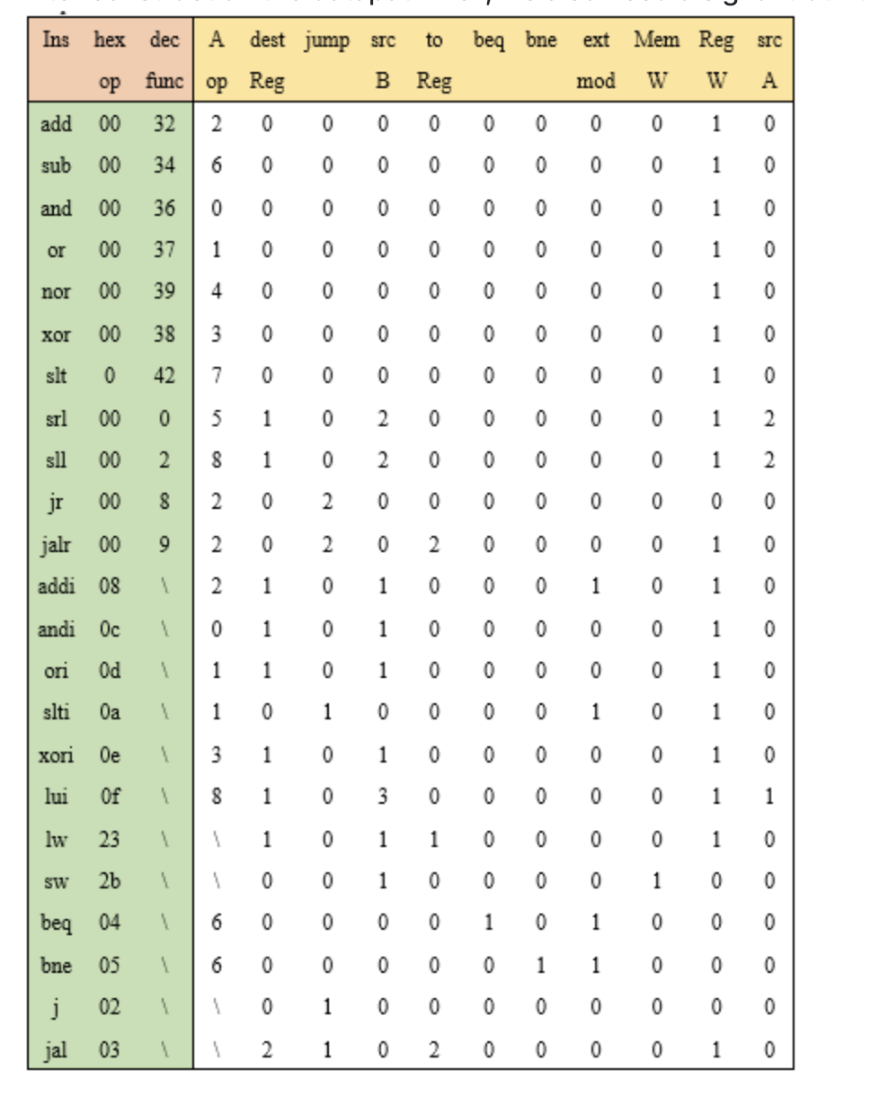
- ALU operation decoding simplified
Simplify Funct variables
ALUop considered separately
Simplify and merge

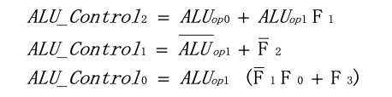
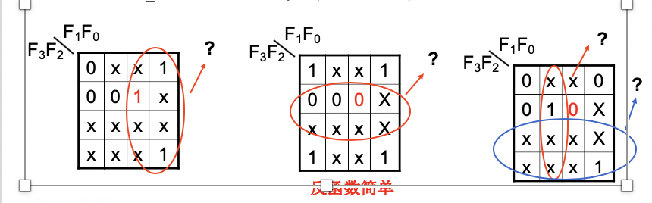
2.4.CPU component data path interface: SCPU_ctrl
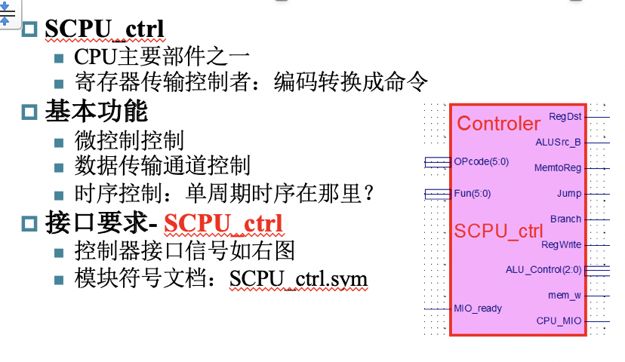
Data path interface signal standard-SCPU_ctrl.v:
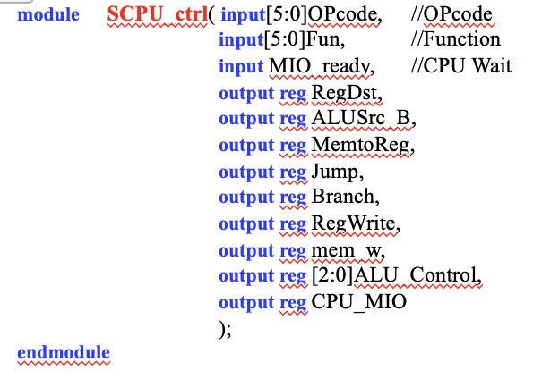
- 实验过程和数据记录
3.1 Design requirements
- Design CPU controller
---According to the analysis and discussion of the theory class, the controller designing the five data paths of the experiment
---Schematic diagram or HDL description can be
---------But it must be described with a function expression structure
---Simulation test controller module
- Integrate and replace the validated data path module
---Replace the SCPU_ctrl.ngc core in Experiment 5 (Exp05)
---Module name: Top_OExp06_OwnSCPU.sch
- Test controller module
---Design test program (MIPS assembly) test:
---OP decoding test:
------R-format, memory access instruction, branch instruction, branch instruction
---Operation control test: Function decoding test
3.2 Design points
- Design the main controller module
---Write the function expression of the controller
---Structure description realization circuit
- Design ALU operation decoding
---Write ALU operation decoding function expression
---Structure description realization circuit
---Use DEMO for initial function debugging
------ALU must include "nor" operation
------Otherwise, you need to modify or redesign the debugging program
- Simulate two controller circuit modules
The simulation can be done separately or combined, but in the end it should be combined into a control module
Circuit to control：
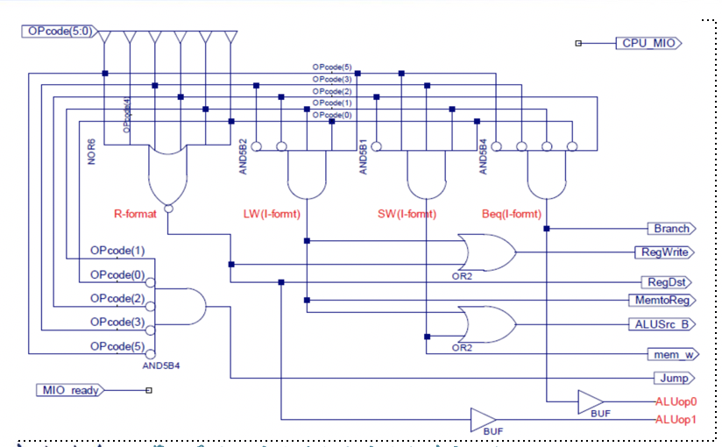

- HDL description structure of main controller
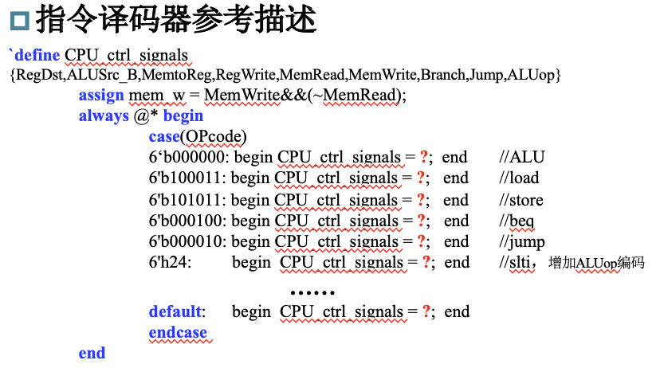

- ALU operation decoder logic circuit
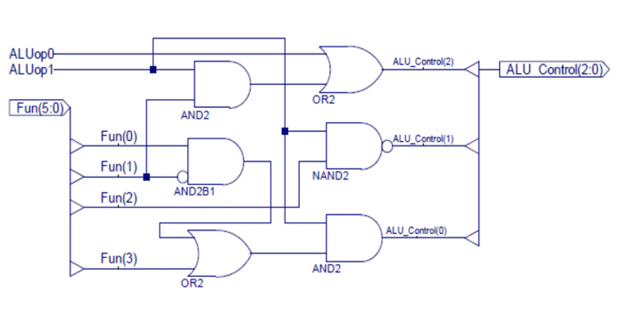

- HDL description structure of ALU operation decoder：
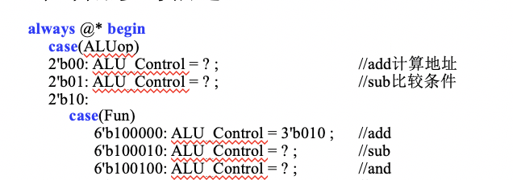

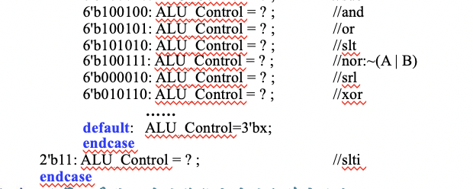
- Controller integrated replacement
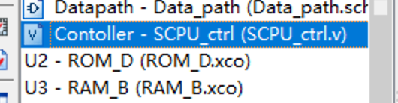
Code：
module SCPU_ctrl(
input wire [5:0] OPcode,
input wire [5:0] Fun,
input wire MIO_ready,
input wire zero,
output reg RegDst,
output reg ALUSrc_B,
output reg [1:0] DatatoReg,
output reg RegWrite,
output reg [2:0] ALU_Control,
output reg mem_w,
output reg [1:0] Branch,
output reg Jal,
output reg CPU_MIO
);

initial begin
RegDst = 0;
ALUSrc_B = 0;
DatatoReg = 2'b00;
RegWrite = 0;
ALU_Control = 3'b000;
mem_w = 0;
Branch = 2'b00;
Jal = 0;
CPU_MIO = 0;
end

always @* begin
case(OPcode)
6'b000000: begin //ALU
if(Fun == 6'b100000)begin //add
ALU_Control = 3'b010; RegDst = 1; ALUSrc_B = 0;
DatatoReg = 2'b00; Jal = 0; Branch = 2'b00; RegWrite = 1; mem_w = 0;end
else if(Fun == 6'b100010)begin //sub
ALU_Control = 3'b110; RegDst = 1; ALUSrc_B = 0;
DatatoReg = 2'b00; Jal = 0; Branch = 2'b00; RegWrite = 1; mem_w = 0;end
else if(Fun == 6'b100100)begin //and
ALU_Control = 3'b000; RegDst = 1; ALUSrc_B = 0;
DatatoReg = 2'b00; Jal = 0; Branch = 2'b00; RegWrite = 1; mem_w = 0;end
else if(Fun == 6'b100101)begin //or
ALU_Control = 3'b001; RegDst = 1; ALUSrc_B = 0;
DatatoReg = 2'b00; Jal = 0; Branch = 2'b00; RegWrite = 1; mem_w = 0;end
else if(Fun == 6'b010110)begin //xor
ALU_Control = 3'b011;RegDst = 1; ALUSrc_B = 0;
DatatoReg = 2'b00; Jal = 0; Branch = 2'b00; RegWrite = 1; mem_w = 0;end
else if(Fun == 6'b100111)begin //nor:~(A | B)
ALU_Control = 3'b100; RegDst = 1; ALUSrc_B = 0;
DatatoReg = 2'b00; Jal = 0; Branch = 2'b00; RegWrite = 1; mem_w = 0;end
else if(Fun == 6'b101010)begin //slt
ALU_Control = 3'b111; RegDst = 1; ALUSrc_B = 0;
DatatoReg = 2'b00; Jal = 0; Branch = 2'b00; RegWrite = 1; mem_w = 0;end
else if(Fun == 6'b000010)begin //srl
ALU_Control = 3'b101; RegDst = 1; ALUSrc_B = 0;
DatatoReg = 2'b00; Jal = 0; Branch = 2'b00; RegWrite = 1; mem_w = 0;end
else if(Fun == 6'b001001)begin //eret
ALU_Control = 3'b010; RegDst = 1; ALUSrc_B = 0;
DatatoReg = 2'b00; Jal = 0; Branch = 2'b11; RegWrite = 1; mem_w = 0;end
else if(Fun == 6'b001000)begin //jr
ALU_Control = 3'b000; RegDst = 1; ALUSrc_B = 0;
DatatoReg = 2'b00; Jal = 1; Branch = 2'b11; RegWrite = 0; mem_w = 0;end
end
6'b100011: begin //load
RegDst = 0; ALU_Control = 3'b010; ALUSrc_B = 1; DatatoReg = 2'b01;
Jal = 0; Branch = 2'b00; RegWrite = 1; mem_w = 0;end
6'b101011: begin //store
RegDst = 1; ALU_Control = 3'b010; ALUSrc_B = 1; DatatoReg = 2'b00;
Jal = 0; Branch = 2'b00; RegWrite = 0; mem_w = 1;end
6'b000100: begin //beq
if(zero == 1)begin
RegDst = 1; ALU_Control = 3'b110; ALUSrc_B = 0; DatatoReg = 2'b00;
Jal = 0; Branch = 2'b01; RegWrite = 0; mem_w = 0;end
else begin
RegDst = 1; ALU_Control = 3'b110; ALUSrc_B = 0; DatatoReg = 2'b00;
Jal = 0; Branch = 2'b00; RegWrite = 0; mem_w = 0;end
end
6'b000101: begin //bne
if(zero == 0)begin
RegDst = 1; ALU_Control = 3'b110; ALUSrc_B = 0; DatatoReg = 2'b00;
Jal = 0; Branch = 2'b01; RegWrite = 0; mem_w = 0;end
else begin
RegDst = 1; ALU_Control = 3'b110; ALUSrc_B = 0; DatatoReg = 2'b00;
Jal = 0; Branch = 2'b00; RegWrite = 0; mem_w = 0;end
end
6'b001010: begin //slti，增加ALUop编码
RegDst = 0; ALU_Control = 3'b111; ALUSrc_B = 1; DatatoReg = 2'b00;
Jal = 0; Branch = 2'b00; RegWrite = 1; mem_w = 0;end
6'b001000: begin //addi
RegDst = 0; ALU_Control = 3'b010; ALUSrc_B = 1; DatatoReg = 2'b00;
Jal = 0; Branch = 2'b00; RegWrite = 1; mem_w = 0;end
6'b001100: begin //andi
RegDst = 0; ALU_Control = 3'b000; ALUSrc_B = 1; DatatoReg = 2'b00;
Jal = 0; Branch = 2'b00; RegWrite = 1; mem_w = 0;end
6'b001101: begin //ori
RegDst = 0; ALU_Control = 3'b001; ALUSrc_B = 1; DatatoReg = 2'b00;
Jal = 0; Branch = 2'b00; RegWrite = 1; mem_w = 0;end
6'b001110: begin //xori
RegDst = 0; ALU_Control = 3'b011; ALUSrc_B = 1; DatatoReg = 2'b00;
Jal = 0; Branch = 2'b00; RegWrite = 1; mem_w = 0;end
6'b000010: begin //j
RegDst = 0; ALU_Control = 3'b000; ALUSrc_B = 0; DatatoReg = 2'b00;
Jal = 0; Branch = 2'b10; RegWrite = 0; mem_w = 0;end
6'b000011: begin //jal
RegDst = 0; ALU_Control = 3'b010; ALUSrc_B = 0; DatatoReg = 2'b11;
Jal = 1; Branch = 2'b10; RegWrite = 1; mem_w = 0;end
6'b001111: begin //lui
RegDst = 0; ALU_Control = 3'b010; ALUSrc_B = 0; DatatoReg = 2'b10;
Jal = 0; Branch = 2'b00; RegWrite = 1; mem_w = 0;end

default: begin
RegDst = 0; ALUSrc_B = 0; DatatoReg = 2'b00; RegWrite = 0;
ALU_Control = 3'b000; mem_w = 0; Branch = 2'b00; Jal = 0;
CPU_MIO = 0; end
endcase
end
endmodule

- 实验结果分析
4.1. test file of the controller:

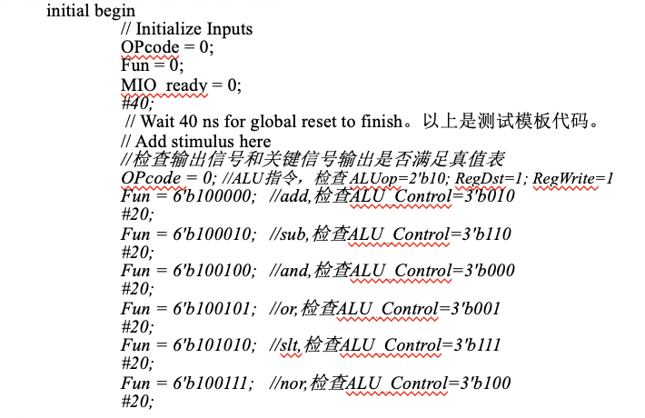
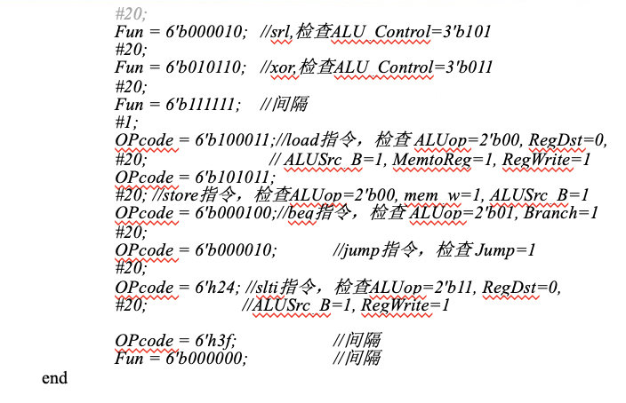
Result:
Check the syntax
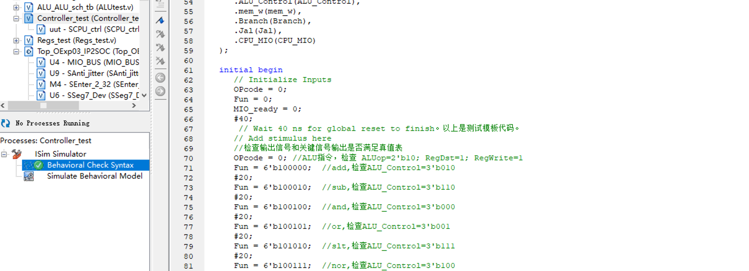

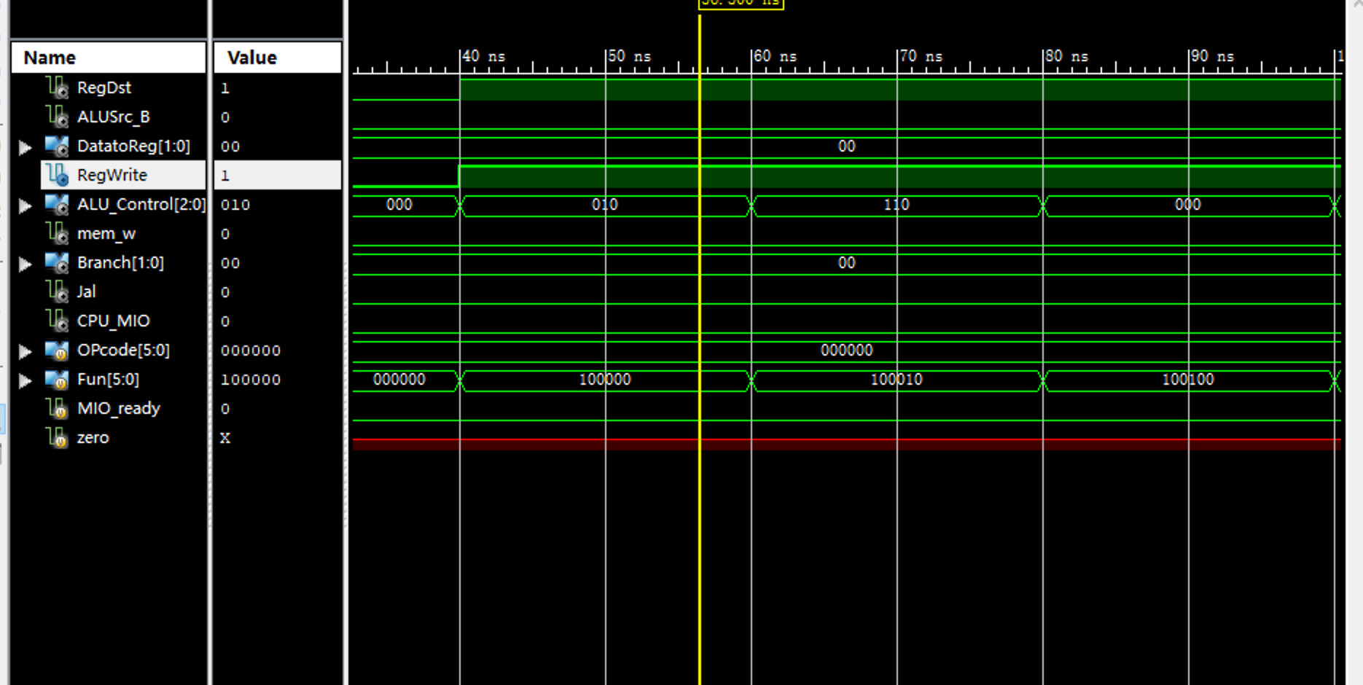

- 实验总结与反思
实验总结和反思会一起汇总到最后的报告7。

